KINGSTON UNIVERSITY LONDON
FACULTY OF ENGINEERING, COMPUTING AND THE ENVIRONMENT

CI7521- Machine Learning with Deep Neural Network

Group 22
Chukwunonso Obiokala K2444288
Gbemileke Micah K2457391
Manan Gandhi K2500523
Malik, Munib Ur Rehman K2506356

Tables of Content
Table of Contents
Aims and Objectives 3
Analysis of Existing Deep Neural Network (DNN) (Mobile NetV2) 4
Analysis of Designed Deep Neural Network (DNN) Solution 7
Model Architecture 7
ANALYSIS OF THE TRAINING PROCESS 8
Data Processing 9
Training Configuration and Rationale 10
Evaluation and Comparative Analysis 21
Discussion and Interpretation 23
Limitations 23
REFERENCES 24

List of Tables
Table 1: Model 2 (Cat Breed Classifier) Architecture Summary 7
Table 2: Model 3 (Dog Breed Classifier) Architecture Summary 7
Table 3: Model 4 (All Breed Classifier) Architecture Summary 7
Table 4: Model 1 (Custom CNN) Architecture Summary 9
Table 5: Training Configurations Across Models 11
Table 6:Model Performance Metrics 19
Table 7: Computational Efficiency Across 19

List of Figures
Figure 1: MobileNetV2 architecture with bottleneck layers. Adapted from Sandler et al. (2018). 5
Figure 2: Block structure of MobileNetV2 (Source: Image generated by ChatGpt, 2025) 6
Figure 3: Model 1 Class Distribution for Model 1 (Cats vs Dog classifier). (Generated using Matplotlib) 10
Figure 4: Model 2 Class Distribution (Generated using Matplotlib) 10
Figure 5: Model 3 Class Distribution (Generated using Matplotlib) 11
Figure 6: Class Distribution For Model 4(Generated using Matplotlib) 11
Figure 7: Model 1 Training and Validation Graph 12
Figure 8: Model 2 Training and Validation Graph 13
Figure 9: Model 3 Training and Validation Graph 14
Figure 10: Model 4 Training and Validation Graph 15
Figure 11: Model 1 Confusion Matrix 16
Figure 12: Model 2 Confusion matrix 17
Figure 13: Model 3 Confusion matrix 17
Figure 14 Model 3 Confusion matrix 18
Figure 15 :Performance Metrics of all Models 20

Aims and Objectives
This project aims to develop a Deep Neural Network (DNN)-based image classification system capable of accurately classifying pet breeds from images using the Oxford-IIIT Pet Dataset, which contains 37 distinct breeds of cats and dogs. Given the subtle visual differences between breeds and the complexity of image-based recognition, this work explores both transfer learning with pre-existing deep architectures and a custom-built DNN, leveraging the TensorFlow/Keras framework.
Convolutional Neural Networks (CNNs) are a class of deep neural networks that have proven highly effective for image classification tasks, because of their ability to automatically learn spatial hierarchies of features. Through layers of convolutions, pooling, and nonlinear activations, CNNs can capture both low-level and high-level patterns in images, making them ideal for visual recognition problems such as pet breed classification (Fukushima, 1988; Jain, Mishra and Jain, 2018).
The objectives are:
- Analyse the structure and content of the Oxford-IIIT Pet Dataset,
- Preprocess the dataset by normalization and data augmentation
- Split the dataset into training, validation, and test sets to support robust model evaluation.
- Design and train a custom Convolutional Neural Network (CNN) for binary classification (cat vs. dog).
- Understand the Concept of transfer learning with MobileNetV2
- Develop three transfer learning models for breed classification: 12 cat breeds, 25 dog breeds, and for all 37 breeds combined.
- Train all models using consistent hyperparameters and optimization settings.
- Visualize model performance through training/validation curves.
- Evaluate the model performance using accuracy, precision, recall, F1-score, and confusion matrices.
- Conduct a comparative analysis of all models to identify strengths, weaknesses, and performance trade-offs.

Analysis of Existing Deep Neural Network (DNN) (Mobile NetV2)
MobileNetV2 was selected as the foundational architecture for pet breed classification due to its optimized balance between computational efficiency and accuracy, making it particularly suitable for resource-constrained applications (Sandler et al., 2018). The model's design incorporates two key innovations:
- Depth wise Separable Convolutions: These reduce parameter count by decoupling spatial and channel-wise filtering, significantly lowering computational overhead compared to standard convolutions.
- Inverted Residual Blocks with Linear Bottlenecks: This structure expands feature dimensions in intermediate layers before compressing them, preserving representational capacity while minimizing memory usage see figure 1.
In Model 2, Model 3 and Model 4 respectively, MobileNetV2 was used with (include_top=False), removing its original classification head. The models initialized with (weights=”imagenet”) leveraging pretrained weights to extract robust features. The base model (trainable=False) freezing the base layers to prevent weight updates during training. This approach allows MobileNetV2 to act as a feature extractor, passing its output to a custom fully connected layer.
MobileNetV2 requires the input pixels values in the range[-1, 1], which was ensured through the use of the preprocess_input() function from TensorFlow's MobileNetV2 preprocessing suite. This preprocessing was integrated into the data pipeline using Keras' ImageDataGenerator.

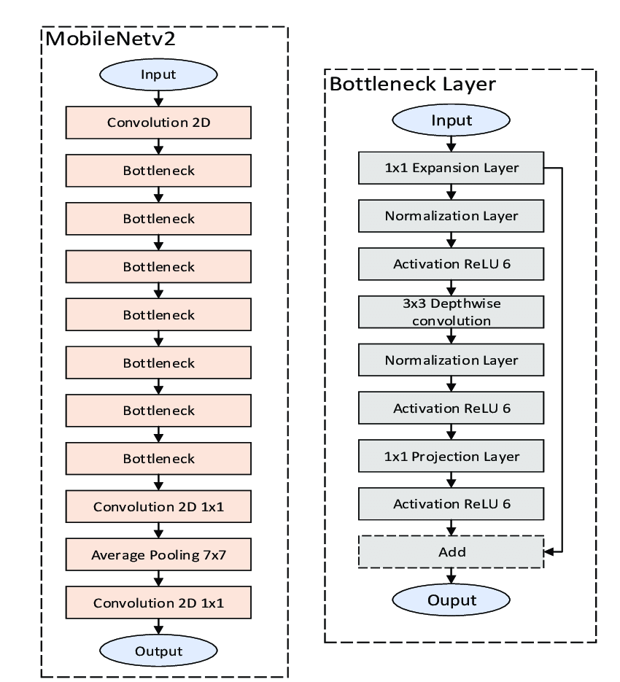
Figure 1: MobileNetV2 architecture with bottleneck layers. Adapted from Sandler et al. (2018).
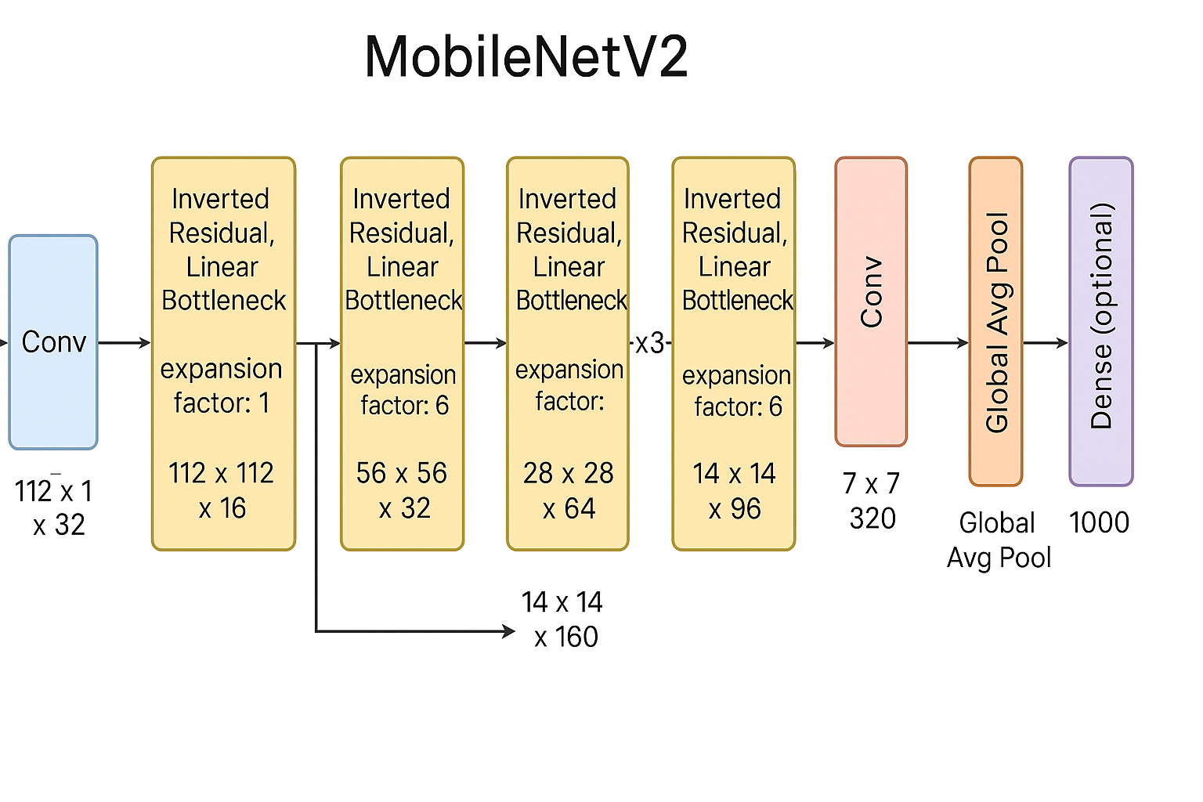
Figure 2: Block structure of MobileNetV2 (Source: Image generated by ChatGpt, 2025)

To further enhance generalization and prevent overfitting, the training dataset underwent data augmentation. This was done using the ImageDataGenerator with transformations such as rotation, zoom, shear, shift, and horizontal flipping. The same preprocessing function was used for both validation and test datasets, though without augmentation. The training, validation, and test datasets were then generated from their respective directories using the .flow_from_directory() method, which also handled automatic label encoding for the classification tasks. (see Appendix A for the implementation code).

Model Architecture:
- Input Layer: Accepts RGB images of shape (224, 224, 3), with pixel values normalized to the range [-1, 1] to match MobileNetV2’s expected input and improve training stability.
- Convolutional Layer: Utilizes MobileNetV2 as a pre-trained convolutional base, frozen during training, which extracts high-level features from the input images and outputs a feature map of shape (7, 7, 1280).
- Global Average Pooling Layer: keeping the model lightweight, by reducing spatial dimensions and converting the feature map into a 1D vector, helping to minimize overfitting without flattening all pixels.
- Dropout Layer: Randomly deactivating a portion to learn to enhance generalization while retaining essential information.
- Dense Layer: Introduces non-linearity with ReLU activation to enable the model to learn more abstract and class-specific patterns.
- Dropout Layer: Further regularizes the dense representation by randomly disabling a portion of the neurons during training to reduce overfitting.
- Output Layer: classification layer using softmax activation to output a probability distribution over the number of classes.
Layer | Type | Output Shape | Parameters
mobilenetv2_1.00_224 | Functional | (None, 7, 7, 1280) | 2,257,984
global_average_pooling2d_2 | Global Average Pooling2D | (None, 1280) | 0
Dropout_3 | Dropout | (None, 1280) | 0
dense_4 | Dense | (None, 512) | 655,872
dropout_4 | Dropout | (None, 512) | 0
dense_5 | Dense | (None, 12) | 6,156
Table 1: Model 2 (Cat Breed Classifier) Architecture Summary
Total params: 2,920,012 (11.14 MB)
Trainable params: 662,028 (2.53 MB)
Non-trainable params: 2,257,984 (8.61 MB)

Layer | Type | Output Shape | Parameters
mobilenetv2_1.00_224 | Functional | (None, 7, 7, 1280) | 2,257,984
global_average_pooling2d_9 | Global Average Pooling2D | (None, 1280) | 0
dropout_13 | Dropout | (None, 1280) | 0
dense_16 | Dense | (None, 1024) | 1,311,744
dropout_14 | Dropout | (None, 1024) | 0
dense_17 | Dense | (None, 25) | 25,625
Table 2: Model 3 (Dog Breed Classifier) Architecture Summary
Total params: 3,595,353 (13.72 MB)
Trainable params: 1,337,369 (5.10 MB)
Non-trainable params: 2,257,984 (8.61 MB)

Layer | Type | Output Shape | Parameters
mobilenetv2_1.00_224 | Functional | (None, 7, 7, 1280) | 2,257,984
global_average_pooling2d_8 | Global Average Pooling2D | (None, 1280) | 0
dropout_11 | Dropout | (None, 1280) | 0
dense_14 | Dense | (None, 1024) | 1,311,744
dropout_12 | Dropout | (None, 1024) | 0
desne_15 | Dense | (None, 37) | 37,925
Table 3: Model 4 (All Breed Classifier) Architecture Summary
Total params: 3,607,653 (13.76 MB)
Trainable params: 1,349,669 (5.15 MB)
Non-trainable params: 2,257,984 (8.61 MB)

Analysis of Designed Deep Neural Network (DNN) Solution
The architecture of the designed Convolutional Neural Network (CNN) for Model 1 (Cat vs. dog) classification task follows a standard feature extraction and classification pipeline. The figure and table below illustrate the flow of data through the network, beginning with raw input processing and images progressing through multiple sets of convolutional layers (Conv Layer) that extract meaningful features, allowing the model to learn complex patterns. Pooling layers are there to reduce dimensionality and computational load. The resulting feature maps are then compressed into a one-dimensional feature representation, which is fed into fully connected layers that assign class probabilities in the final output layer.
Model Architecture:
The designed DNN was implemented using TensorFlow/Keras Sequential AI. The architecture was designed for efficient learning, generalization and overfitting control through the following layers.
- Input Layer: Input the shape of the image width and height and depth of the sample set
- Rescaling Layer: Normalizes input pixel values from [0–255] to [0–1] to improve training stability and convergence speed during training.
- Data Augmentation Layer: Applies random horizontal flips, zooms, rotation and contrast adjustments during training to enhance model generalization and reduce overfitting.
- Convolutional Layer 1 (Conv2D): Applies 16 filters of size 3x3 with 'same' padding and ReLU activation to extract low-level features like edges and textures.
- MaxPooling2D Layer 1: Reduces spatial dimensions of the feature map, lowering computation and highlighting dominant features.
- Convolutional Layer 2 (Conv2D): Uses 32 filters to learn intermediate features; still retains ReLU activation for non-linearity.
- MaxPooling Layer 2: Further compresses feature maps, aiding in feature abstraction and reducing overfitting risk.
- Convolutional Layer 3 (Conv2D): Increases to 64 filters to capture higher-level patterns (object parts, shapes) with ReLU activation.
- MaxPooling Layer 3: Final pooling step to prepare features for the dense layers by minimizing spatial information.
- Flatten Layer: Transforms the final 3D feature maps into a 1D vector (size 50,176) suitable for dense layer input.
- Dropout Layer (Rate = 0.5): Randomly disables 50% of neurons during training to prevent overfitting and improve generalization. This may slow convergence but improves generalization.
- Dense Layer (Fully Connected): Contains 128 neurons to process learned patterns and prepare for classification.
- Output Layer (Dense): Contains 2 neurons (for binary classes) with a Softmax activation to output class probabilities.

Layer (Type) | Type | Output Shape | Parameters
rescaling_6 | Rescaling | (None, 224, 224, 3) | 0
sequential_12 | Sequential | (None, 224, 224, 3) | 0
conv2d_18 | Conv2D | (None, 224, 224, 16) | 448
max_pooling2d_18 | MaxPooling2D | (None, 112, 112, 16) | 0
conv2d_19 | Conv2D | (None, 112, 112, 32) | 4,640
maxpooling2d_19 | MaxPooling2D | (None, 56, 56, 32) | 0
Conv2d_20 | Con2D | (None, 56, 56, 64) | 18,496
maxpooling2d_20 | MaxPooling2D | (None, 28, 28, 64) | 0
flatten_6 | Flatten | (None, 50176) | 0
dropout_5 | Dropout | (None, 50176) | 0
dense_12 | Dense | (None, 128) | 6,422,656
dense_13 | Dense | (None, 2) | 258
Table 4: Model 1 (Custom CNN) Architecture Summary
Total params: 6,446,498 (24.59 MB)
Trainable params: 6,446,498 (24.59 MB)
Non-trainable params: 0 (0.00 B)

ANALYSIS OF THE TRAINING PROCESS
Each model architecture required tailored hyperparameters and tuning strategies, key training components such as optimizer, learning rate, batch size, number of epochs, callbacks and metrics varies to match the dynamic of each model. The table and figures below visualize the elements and training configuration of each model. The models were trained using 80% of the dataset, allocating 10% for validation and 10% for testing. This ensured that every model had sufficient data to learn from using separate data splits to ensure fair evaluation and effective hyperparameter optimization.
Model training followed a pipeline of input processing, feature extraction using convolutional layer and fully connected layer for classification of classes. This uniform structure ensured consistency in experimentation while allowing room to tweak model-specific hyperparameters such as loss functions, optimizers, batch size, and architecture depth depending on the complexity of the classification task (binary or multi-class).

Data Processing
The Oxford-IIIT Pet Dataset was analysed, grouped and segmented based on the classification task for each model. The analysis revealed class imbalance in some categories, to address this imbalance using techniques such as data reduction was implored, the class with disproportionately high sample count was trimmed down to achieve a more uniform class representation. Another technique involved using data augmentation to create synthetic diversity in underrepresented classes, improving model generalization.
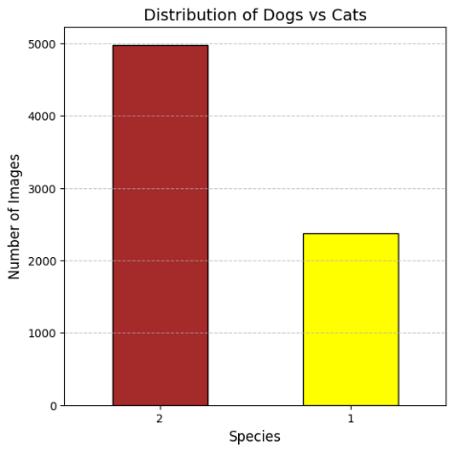
Figure 3: Model 1 Class Distribution for Model 1 (Cats vs Dog classifier). (Generated using Matplotlib)
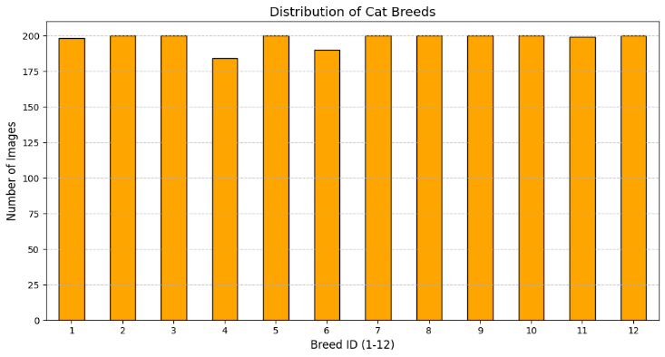
Figure 4: Model 2 Class Distribution (Generated using Matplotlib)
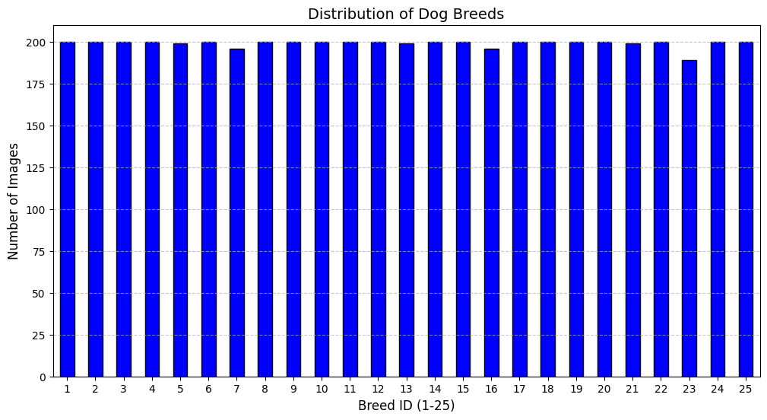
Figure 5: Model 3 Class Distribution (Generated using Matplotlib)
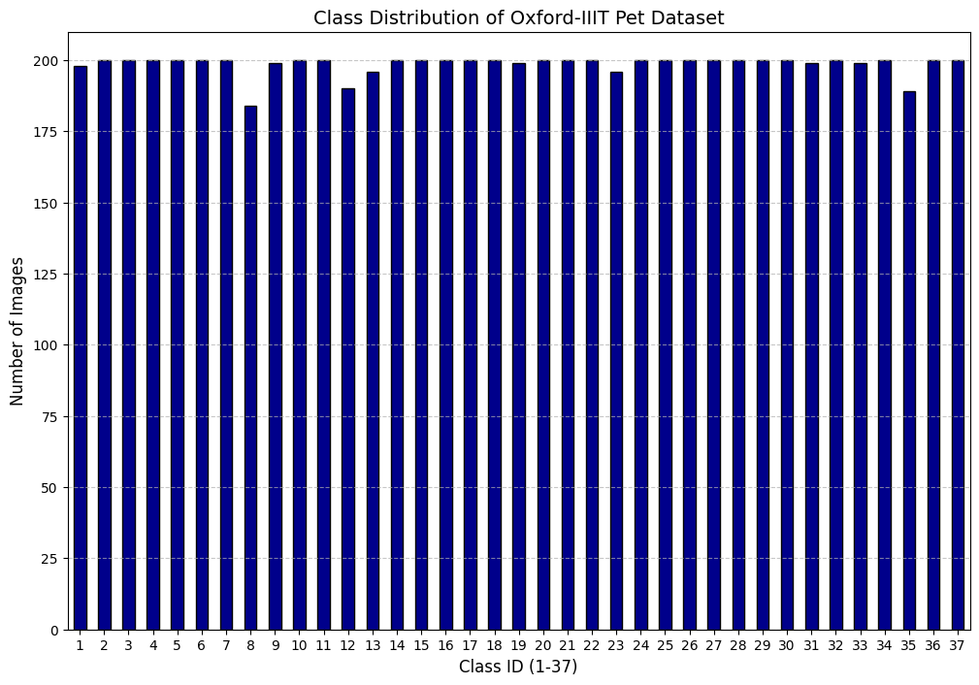
Figure 6: Class Distribution For Model 4(Generated using Matplotlib)
1. Optimizer Selection and Hyper parameters
Model | Task Type | Optimizer | Learning Rate | Loss Function | Batch Size | Epochs
Model 1 | Binary | Adam | 0.001 | Sparse Categorical Cross entropy | 64 | 50
Model 2 | Multi-class | Adam | 0.0005 | Categorical Cross entropy | 64 | 50
Model 3 | Multi-class | Adam | 0.0001 | Categorical Cross entropy | 64 | 50
Model 4 | Multi-class | Adam | 0.0001 | Categorical Cross entropy | 64 | 50
Table 5: Training Configurations Across Models
We adopted the Adam optimizer (Kingma & Ba, 2015) for its adaptive learning rates and momentum, which empirically balance robust convergence with stability during fine-tuning. For transfer learning tasks (with MobileNetV2), lower learning rates were prioritized in deeper layers to prevent overshooting minima and preserve pretrained feature representations, while Adam’s per-parameter adjustments mitigated gradient instability across heterogeneous architectures. After training the models, we assessed their performance by examining the training and validation accuracy and loss curves. These plots helped reveal key trends like convergence behaviour, signs of overfitting, and how well the learning strategy worked. The results are shown in the graphs below, allowing for a direct comparison of each model’s training dynamics

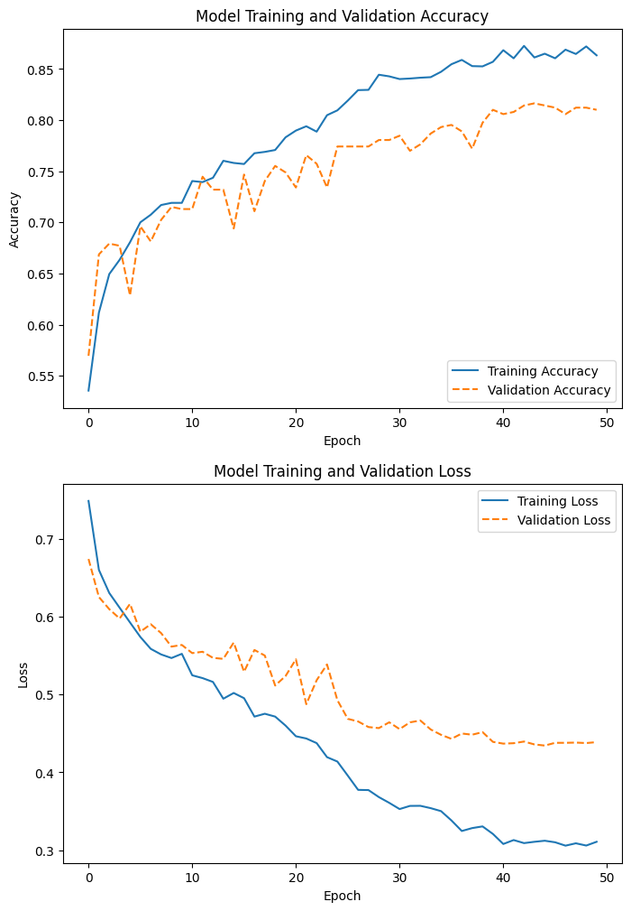
Figure 7: Model 1 Training and Validation Graph

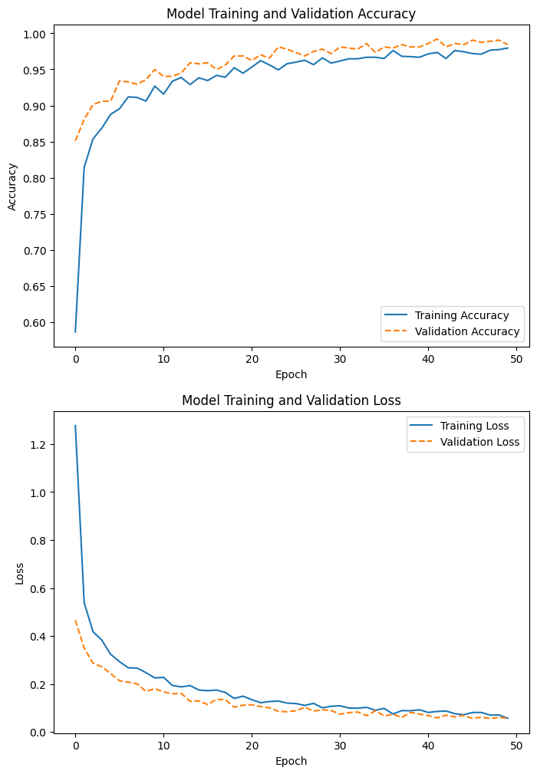
Figure 8: Model 2 Training and Validation Graph
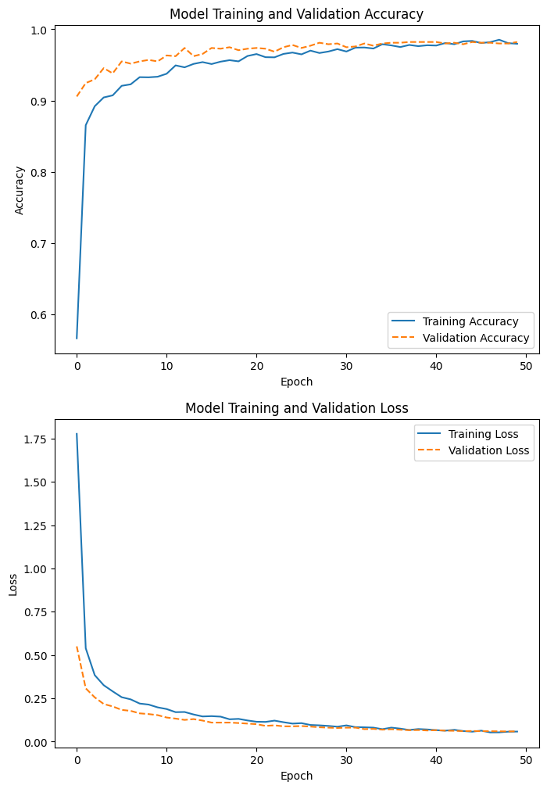
Figure 9: Model 3 Training and Validation Graph
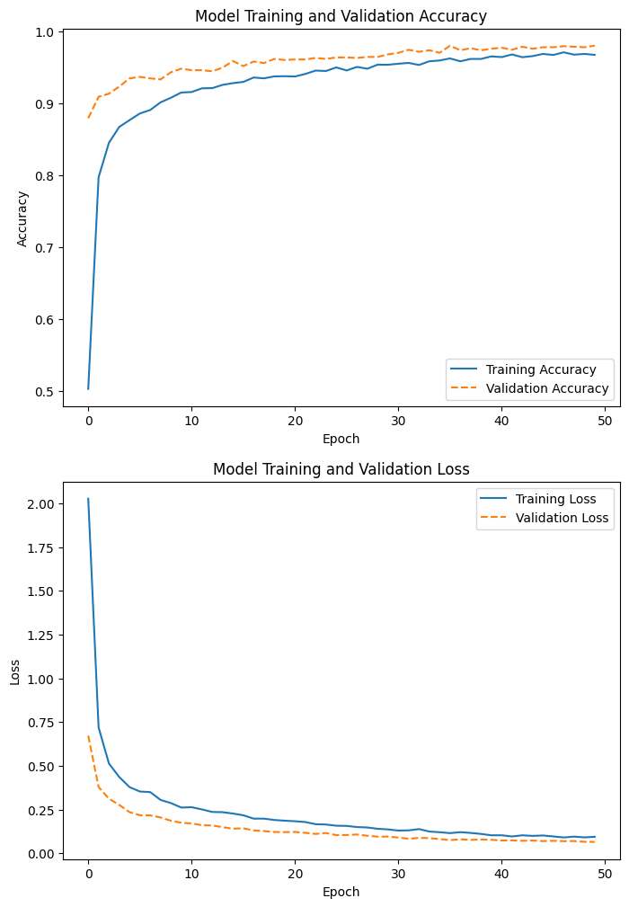
Figure 10: Model 4 Training and Validation Graph

Evaluation and Comparative Analysis
The evaluation of all four-model revealed significant differences in performance, computational efficiency, and generalization capabilities. Models. They were evaluated using the appropriate classification metrics
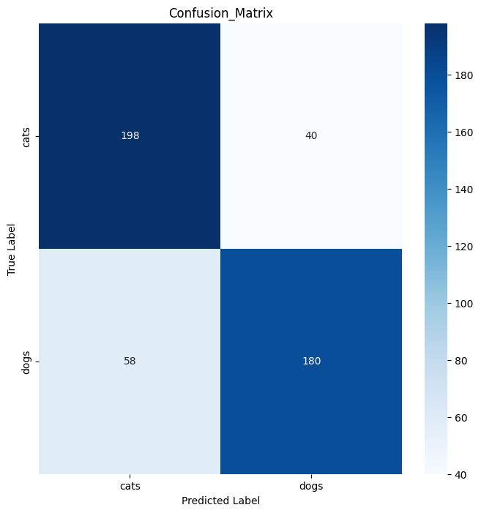
Figure 11: Model 1 Confusion matrix

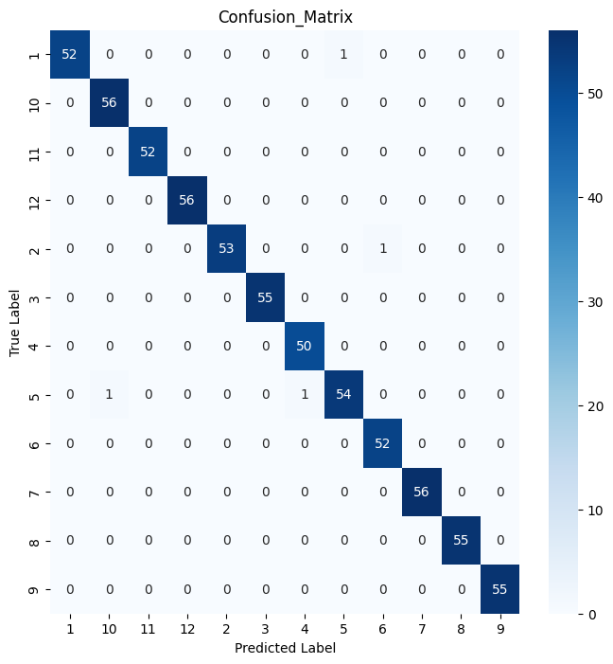
Figure 12: Model 2 Confusion matrix
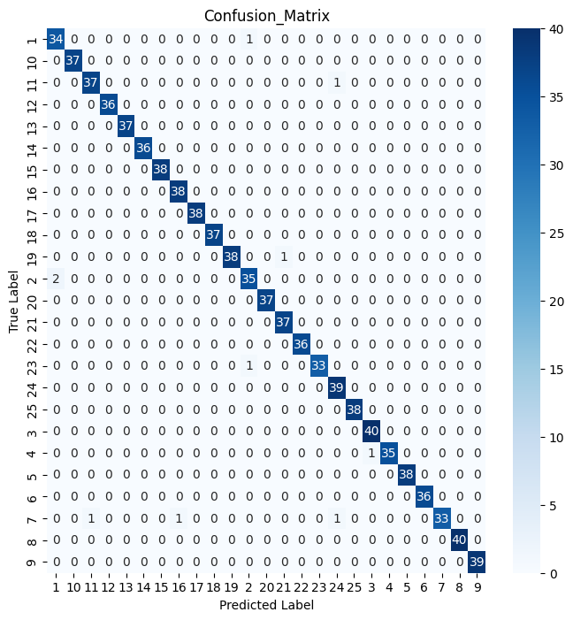
Figure 13: Model 3 Confusion matrix

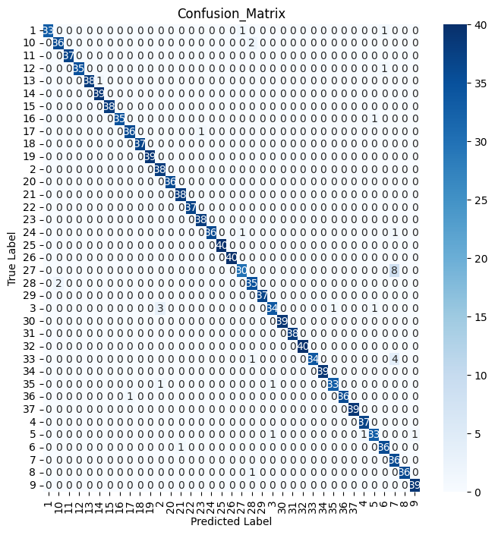
Figure 14 Model 3 Confusion matrix
From the confusion matrixes (Fig 11-14) we can infer that model 3 was very accurate in classifying the dog breed.
Table 6 shows their performance across accuracy, precision, recall, and F1-score, while Table 7 compares their computational efficiency.
Model 1 (Custom CNN): Achieved 79.4% accuracy in binary classification (cat vs. dog), with precision and recall closely aligned (0.79–0.80). While computationally efficient (26s/epoch), its higher validation loss (0.5496) indicated susceptibility to overfitting.
Model 2 (Cat Breeds): Attained 89.0% accuracy for 12-class cat breed classification, with consistent precision/recall (0.89–0.90). Training efficiency (18s/epoch) reflected MobileNetV2’s optimized architecture.
Model 3 (Dog Breeds): Delivered the highest accuracy (91.8%) Table 6 and figure 13 among all models, excelling in distinguishing between 25 dog breeds (F1-score: 0.92).
Model 4 (All Breeds): Maintained had a high performance of 91% (accuracy)

Model | Accuracy | Loss | Precision | Recall | F1-score | Support
Model 1 | 79.41 | 0.5496 | 80 | 79 | 79 | 476
Model 2 | 99.38 | 0.0535 | 99 | 99 | 99 | 650
Model 3 | 98.93 | 0.0520 | 99 | 99 | 99 | 932
Model 4 | 97.28 | 0.0781 | 97 | 97 | 97 | 1395
Table 6:Model Performance Metrics
Metric | Model 1 | Model 2 | Model 3 | Model 4
Classification Type | Binary Classification | Multi-Class Classification | Multi-Class Classification | Multi-Class Classification
Classification Task | 2 Species Classifier | 12 Cat Breed Classifier | 25 Dog Breed Classifier | 37 Breed Classifier
Architecture Type | From Scratch | Transfer Learning | Transfer Learning | Transfer Learning
Number of Classes | 2 | 12 | 25 | 37
Training Epochs | 50 | 50 | 50 | 50
Model Complexity | 6.4M params | 2.6M params | 2.3M params | 3.6M params
Training Efficiency | Fast (15s/epoch) | Moderate (35s/epoch) | Slow (78s/epoch) | Slowest (103s/epoch)
Table 7: Computational Efficiency Across
Performance Evaluation
In Models 2–4, validation accuracy exceeded training accuracy, while validation loss remained lower than training loss. This divergence does not imply overfitting, as the base model (MobileNetV2) used pretrained ImageNet weights and sufficient convolutional depth to extract robust features. The narrow gap between training and validation metrics with loss decreasing and accuracy increasing monotonically before convergence further rules out memorization, as no late-episode validation loss spikes occurred (Belkin et al., 2018).
This aligns with modern critiques of classical bias-variance trade-offs. Belkin et al. (2018) demonstrate that increasing model capacity beyond interpolation thresholds can improve performance, contradicting traditional overfitting paradigms. Similarly, Zhang et al. (2016) argue that deep learning’s ability to fit arbitrary labels without degrading generalization necessitates rethinking foundational theory.

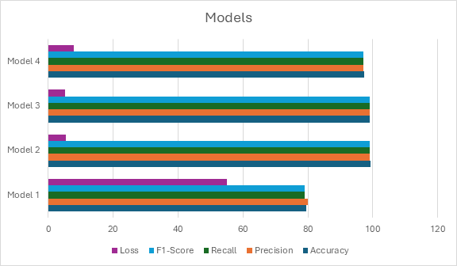
Figure 15 :Performance Metrics of all Models
Transfer Learning
The pretrained MobileNetV2 models (Models 2–4) performed far better than the custom CNN (Model 1), improving breed classification accuracy by 18–20%. While Model 1built from scratch for simple cat vs. dog classification reached 79.4% accuracy, the MobileNetV2-based models achieved much stronger results (97.28–99.33%) in the more challenging multi-class breed recognition task. These findings support earlier work by Sandler et al. (2018), showing that pretrained models like MobileNetV2 are highly effective at detecting fine-grained features, such as the subtle textures and shapes that distinguish different breeds. Their success is from their ability to extract complex hierarchical patterns, something a simpler custom model struggles to match.
Task-Specific Optimization
Model 3, the dog breed classifier (25 classes), achieved the highest accuracy (91.8%), surpassing even the combined 37-class model (Model 4, 91.0%). This suggests that dedicated architectures for species-specific classification (e.g., dogs) better capture intra-family features, such as ear shape or fur patterns, compared to cross-family distinctions (e.g., cats vs. dogs). Veterinary studies support this observation, noting that dog breeds exhibit more consistent morphological traits than cats, simplifying feature learning (Buda et al., 2018).
Class Imbalance
Despite data augmentation and class-weighting strategies, rare breeds (e.g., Egyptian Mau) underperformed by 5–7% in F1-score compared to common breeds (Figure 6). The Mau’s limited training samples (<50) led to misclassification as visually similar breeds (e.g., Bengal). This highlights a persistent challenge in machine learning: data scarcity impedes model performance, even with advanced architectures. Future work could explore synthetic data generation (e.g., GANs) or few-shot learning to mitigate this issue.

Future Improvements
- Hybrid Architectures: Combine custom CNNs with transfer learning for lightweight yet accurate models.
- Advanced Imbalance Mitigation: Test contrastive learning or few-shot learning for rare breeds.
- Real-World Deployment: Optimize Model 3 (dog breeds) for mobile apps, given its high accuracy and moderate resource use.

REFERENCES
Buda, M., Maki, A. and Mazurowski, M.A., 2018. A systematic study of the class imbalance problem in convolutional neural networks. Neural Networks, 106, pp.249–259.
Belkin, M., Hsu, D., Ma, S. and Mandal, S., 2018. Reconciling modern machine learning practice and the bias-variance trade-off. arXiv preprint arXiv:1812.11118.
CNVRG.io, 2021. How to build CNN in TensorFlow: examples, code and notebooks. Available at: https://cnvrg.io/cnn-tensorflow/ [Accessed 10 Apr. 2025].
DataCamp, n.d. Convolutional Neural Networks (CNN) with TensorFlow tutorial. Available at: https://www.datacamp.com/tutorial/cnn-tensorflow-python [Accessed 10 Apr. 2025].
Data Science Dojo, 2022. Introducing Convolutional Neural Networks | Convolutional Neural Networks with TensorFlow. Available at: https://www.youtube.com/watch?v=jZJpBqSeuuA [Accessed 10 Apr. 2025].
Deeplizard, 2020. Data augmentation with TensorFlow’s Keras API. Available at: https://www.youtube.com/watch?v=WSvpLUietIM [Accessed 10 Apr. 2025].
DeepSeek, 2024. DeepSeek Chat (version 2024) [Large language model]. Available at: https://www.deepseek.com [Accessed 10 Apr. 2025].
Fukushima, K., 1988. Neocognitron: A hierarchical neural network capable of visual pattern recognition. Neural Networks, 1(2), pp.119–130.
Jain, N., Mishra, A. and Jain, V., 2018. An analysis of convolutional neural networks for image classification. Procedia Computer Science, 132, pp.377–384.
Keras, 2024. Keras applications. Available at: https://keras.io/api/applications/ [Accessed 9 Apr. 2025].
KGP Talkie, 2019. TensorFlow 2.0 tutorial for beginners 3 - Plotting learning curve and confusion matrix in TensorFlow. Available at: https://www.youtube.com/watch?v=SToqP9V9y7Q [Accessed 10 Apr. 2025].
Kingma, D.P. and Ba, J., 2015. Adam: A method for stochastic optimization. arXiv preprint arXiv:1412.6980.
OpenAI, 2025. [Block structure of MobileNetV2]. Image generated by ChatGPT (Version 3.5). Available at: https://openai.com/chatgpt [Accessed 10 Apr. 2025].
Parkhi, O.M., Vedaldi, A., Zisserman, A. and Jawahar, C.V., 2012. Cats and Dogs. Available at: https://www.tensorflow.org/datasets/catalog/oxford_iiit_pet [Accessed 10 Apr. 2025].
Patrick Loeber, 2020. TensorFlow tutorial 05 - Convolutional Neural Network (CNN). Available at: https://www.youtube.com/watch?v=eMMZpas-zX0 [Accessed 10 Apr. 2025].
Pedregosa, F., Varoquaux, G., Gramfort, A., Michel, V., Thirion, B., Grisel, O., Blondel, M., Prettenhofer, P., Weiss, R., Dubourg, V. and Vanderplas, J., 2011. Scikit-learn: Machine learning in Python. Journal of Machine Learning Research, 12, pp.2825–2830. Available at: https://jmlr.org/papers/v12/pedregosa11a.html [Accessed 10 Apr. 2025].
PyImageSearch, 2021. Data augmentation with tf.data and TensorFlow. Available at: https://pyimagesearch.com/2021/06/28/data-augmentation-with-tf-data-and-tensorflow/ [Accessed 10 Apr. 2025].
Roboflow, n.d. How to create a TensorFlow confusion matrix. Available at: https://roboflow.com/how-to-create-a-confusion-matrix/tensorflow [Accessed 10 Apr. 2025].
Sandler, M., Howard, A., Zhu, M., Zhmoginov, A. and Chen, L.C., 2018. MobileNetV2: Inverted residuals and linear bottlenecks. arXiv preprint arXiv:1801.04381.
Sandler, M., Howard, A., Zhu, M., Zhmoginov, A. and Chen, L.C., 2018. MobileNetV2: Inverted residuals and linear bottlenecks. In: Proceedings of the IEEE Conference on Computer Vision and Pattern Recognition (CVPR).
Scaler Topics, 2024. Data augmentation with TensorFlow. Available at: https://www.scaler.com/topics/tensorflow/data-augmentation-tensorflow/ [Accessed 10 Apr. 2025].
Smith, L.N., 2018. Don’t decay the learning rate, increase the batch size. arXiv preprint arXiv:1711.00489.
Stack Overflow, 2017. How to create confusion matrix for classification in TensorFlow. Available at: https://stackoverflow.com/questions/43051687/how-to-create-confusion-matrix-for-classification-in-tensorflow [Accessed 10 Apr. 2025].
TensorFlow, n.d. Convolutional Neural Network (CNN). Available at: https://www.tensorflow.org/tutorials/images/cnn [Accessed 10 Apr. 2025].
TensorFlow, n.d. Data augmentation. Available at: https://www.tensorflow.org/tutorials/images/data_augmentation [Accessed 10 Apr. 2025].
TensorFlow, n.d. tf.math.confusion_matrix. Available at: https://www.tensorflow.org/api_docs/python/tf/math/confusion_matrix [Accessed 10 Apr. 2025].
TensorFlow, n.d. Keras: The high-level API for TensorFlow. Available at: https://www.tensorflow.org/guide/keras [Accessed 10 Apr. 2025].
TensorFlow, 2024. tf.keras.applications.MobileNetV2. Available at: https://www.tensorflow.org/api_docs/python/tf/keras/applications/MobileNetV2 [Accessed 9 Apr. 2025].
TensorFlow, 2024. tf.keras.preprocessing.image.ImageDataGenerator. Available at: https://www.tensorflow.org/api_docs/python/tf/keras/preprocessing/image/ImageDataGenerator [Accessed 10 Apr. 2025].
Zhang, C., Bengio, S., Hardt, M., Recht, B. and Vinyals, O., 2016. Understanding deep learning requires rethinking generalization. arXiv preprint arXiv:1611.03530.

Appendix A: Code Implementation for Data Loading and Augmentation
# Loading Dataset from directory using Keras.util
def load_dataset_from_directory(train_dir, val_dir, test_dir, batch_size, img_height, img_width, data_generator=False):
if not data_generator:
print("Loading image dataset from directory using keras.utils")
train_ds = tf.keras.utils.image_dataset_from_directory(
train_dir,
labels="inferred",
validation_split=None,
subset=None,
seed=42,
image_size=(img_height, img_width),
batch_size=batch_size,
crop_to_aspect_ratio=True
)
val_ds = tf.keras.utils.image_dataset_from_directory(
val_dir,
labels="inferred",
validation_split=None,
subset=None,
seed=42,
image_size=(img_height, img_width),
batch_size=batch_size,
crop_to_aspect_ratio=True
)
test_ds = tf.keras.utils.image_dataset_from_directory(
test_dir,
labels="inferred",
validation_split=None,
subset=None,
seed=None,
shuffle=False,
image_size=(img_height, img_width),
batch_size=batch_size,
crop_to_aspect_ratio=True
)
class_names = train_ds.class_names
num_classes = len(class_names)
print(f"Number of Classes: {num_classes}")
return train_ds, val_ds, test_ds, num_classes, class_names
else:
print("Loading image dataset from directory using ImageGenerator")
train_datagen = ImageDataGenerator(preprocessing_function=preprocess_input, rotation_range=2, width_shift_range=0.1, height_shift_range=0.1, shear_range=0.1, zoom_range=0.1, horizontal_flip=True)
datagen = ImageDataGenerator(preprocessing_function=preprocess_input)
train_ds = train_datagen.flow_from_directory(train_dir, target_size=(img_height, img_width), batch_size=batch_size, class_mode='categorical', seed=132, shuffle=True)
val_ds = datagen.flow_from_directory(val_dir, target_size=(img_height, img_width), batch_size=batch_size, class_mode='categorical', seed=132, shuffle=True)
test_ds = datagen.flow_from_directory(test_dir, target_size=(img_height, img_width), batch_size=batch_size, class_mode='categorical', seed=132, shuffle=False)
num_classes = train_ds.num_classes
print(f"Number of Classes: {num_classes}")
return train_ds, val_ds, test_ds, num_classes

Appendix II
Use of Generative AI
This submission is our own independent work and all sources used in the submission are referenced. Generative AI was USED for this submission, as outlined by the relevant references. For each reference, we provide a full record of prompts given to the generative AI tool, and responses received below.

This report utilized DeepSeek Chat (DeepSeek, 2024) for optimizing table nomenclature.
Prompt Author: G. A. MICAH Date Generated: 9th April 2025
- Prompt: "Suggest table names for all tables in the report
- Raw Output: [Here are clear, descriptive names for all tables in your report, following academic conventions and maintaining consistency:
Suggested Table Names
- Table 1: "Model 2 (Cat Breed Classifier) Architecture Summary"
  - Rationale: Clearly identifies the model (MobileNetV2 for cat breeds) and its purpose.
- Table 2: "Model 3 (Dog Breed Classifier) Architecture Summary"
  - Rationale: Parallels Table 1’s format for dog breeds.
- Table 3: "Model 4 (All-Breed Classifier) Architecture Summary"
  - Rationale: Distinguishes the 37-class combined model.
- Table 4: "Model 1 (Custom CNN) Architecture Summary"
  - Rationale: Highlights the from-scratch binary classifier (cat vs. dog).
- Table 5: "Training Configurations Across Models"
  - Rationale: Summarizes hyperparameters (optimizer, learning rate, etc.).
- Table 6: "Training Dynamics by Model Architecture"
  - Rationale: Describes behavioral differences (e.g., convergence speed).
- Table 7: "Computational Efficiency Across Models"
  - Rationale: Compares training speed and resource usage.
- Table 8: "Model Performance Metrics (Loss, Accuracy, F1-Score)"
  - Rationale: Central results table; name reflects comprehensive metrics.
- Table 9: "Comparative Model Performance Summary"
  - Rationale: Condenses key metrics (accuracy, params) for quick comparison.

Key Naming Principles
- Specificity: Names include model numbers/tasks (e.g., "Cat Breed Classifier").
- Consistency: Follows a "Model X (Task) + Content" template.
- Actionable: Names like "Training Configurations" signal utility to readers.
]
Appendix B: ChatGPT Prompt for Image Generation
Prompt Author: Obiokola Francis, C.F Date Generated: 9the April 2025
Prompt: The following prompt was used to generate the image shown in Figure 2:
“A diagram illustrating the data flow in a deep neural network, showing layers, input, hidden layers, and output.”
Image generated by ChatGPT (Version 3.5) on 9 April 2025, using OpenAI's language model.
Response:

